Worksheet 1

Student Name:Suyash UID:25MCI10054
Branch:MCA (AI&ML) Section/Group:MAM-1 A
Semester:2nd Date of Performance:07/01/2026
Subject Name:- DBMS LAB Subject Code:

1. Aim of the Session

To design and implement a sample database system using DDL, DML, and DCL commands for managing departments, employees, and projects, and to apply role-based access control for secure data handling.

2. Software Requirements
- PostgreSQL (Database Server)
- pgAdmin
- Windows Operating System

3. Objective of the Session

After completing this practical, the student will be able to:
- Understand the use of DDL commands to create and modify database structures.
- Perform DML operations such as INSERT, UPDATE, DELETE, and SELECT.
- Implement relationships using primary and foreign keys.
- Apply DCL commands to manage roles and privileges.
- Analyze input and output of SQL queries in a real database environment.

4. Practical / Experiment Steps

Design the database schema for Department, Employee, and Project tables.

Create tables using appropriate constraints.

Insert sample records into tables.

Perform update and delete operations.

Retrieve data using SELECT queries.

Create a role and grant/revoke privileges.

Alter and drop database objects.

5. Procedure of the Practical

(i) Start the system and log in to the computer.

(ii) Open PostgreSQL software.

(iii) create database CompanyDB;

(iv) Create tables using DDL commands.

(i) create table Department

CREATE TABLE Department (

dept_id int PRIMARY KEY,

dept_name VARCHAR(50) UNIQUE NOT NULL,

location VARCHAR(50) NOT NULL

);

(ii) create table Employee

CREATE TABLE Employee (

emp_id int PRIMARY KEY,

emp_name VARCHAR(50) NOT NULL,

email VARCHAR(50) UNIQUE NOT NULL,

salary int CHECK (salary > 0),

dept_id int,

CONSTRAINT fk_dept FOREIGN KEY (dept_id) REFERENCES Department(dept_id)

);

(iii) create table Project

CREATE TABLE Project (

project_id int PRIMARY KEY,

project_name VARCHAR(50) NOT NULL,

dept_id int,

CONSTRAINT fk_project_dept FOREIGN KEY (dept_id)

REFERENCES Department(dept_id)

);

(iv) Insert records using DML commands.

insert into Department values

INSERT INTO Department VALUES

(1, 'HR', 'Mumbai'),

(2, 'IT', 'Pune'),

(3, 'Finance', 'Delhi'),

(4, 'Marketing', 'Bangalore'),

(5, 'Operations', 'Chennai');

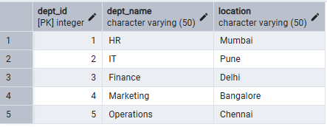

(v) insert into Employee values

INSERT INTO Employee VALUES

(101, 'Amit', 'amit@org.com', 40000, 2),

(102, 'Neha', 'neha@org.com', 35000, 1),

(103, 'Rohit', 'rohit@org.com', 50000, 2),

(104, 'Pooja', 'pooja@org.com', 38000, 3),

(105, 'Karan', 'karan@org.com', 42000, 4),

(106, 'Sneha', 'sneha@org.com', 36000, 5),

(107, 'Anjali', 'anjali@org.com', 47000, 2);

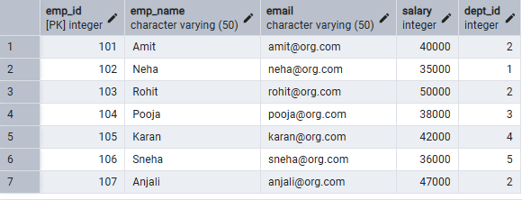

(vi) insert into Project values

INSERT INTO Project VALUES

(201, 'Payroll System', 1),

(202, 'Web Portal', 2),

(203, 'Accounting Software', 3),

(204, 'Ad Campaign', 4),

(205, 'Inventory System', 5),

(206, 'Mobile App', 2);

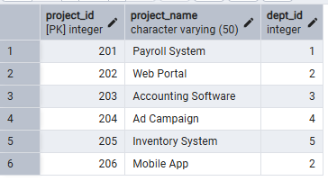

(vii) Update and delete records.

UPDATE Employee

SET salary = 45000

WHERE emp_id = 101;

DELETE FROM Projects

WHERE dept_id = 2;

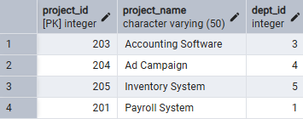

(viii) Create role and assign privileges.

CREATE ROLE report_user LOGIN PASSWORD 'report123';



GRANT SELECT ON Department TO report_user;

GRANT SELECT ON Employee TO report_user;

GRANT SELECT ON Project TO report_user;

REVOKE CREATE ON SCHEMA public FROM report_user;

(ix) Alter and drop table.

ALTER TABLE Employee

ADD phone_number VARCHAR(15);

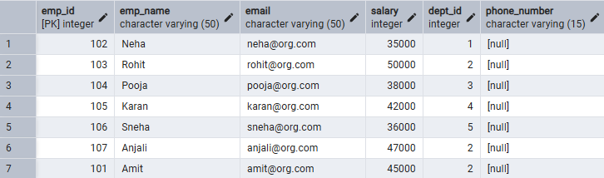

(x) drop table Project;

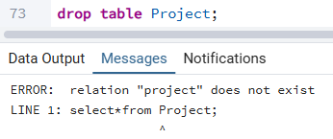

6. I/O Analysis (Input / Output)

Input:

• Department, Employee, and Project table creation queries
• Records inserted into all tables using INSERT commands
• Update query to modify employee department
• Delete queries to remove project and employee records
• Role creation and privilege assignment queries
• ALTER and DROP table commands

Output:

• Department, Employee, and Project tables created successfully
• Records inserted, updated, and deleted correctly
• Referential integrity maintained between tables
• Data displayed correctly using SELECT queries
• Role-based access verified using GRANT and REVOKE
• Table structure modified and project table dropped successfully

Screenshots of execution and obtained results are attached.

7.Learning Outcomes
- Create database tables using DDL commands with appropriate constraints to ensure data integrity.
- Perform DML operations such as INSERT, UPDATE, and DELETE on database records.
- Establish relationships between tables using PRIMARY KEY and FOREIGN KEY constraints.
- Implement role-based access control using DCL commands to provide secure, read-only access.
- Modify and manage database schemas using ALTER TABLE and DROP TABLE commands.

